**PRACTICAL NO-5**

**Aim : Study And Implementation Of Identity Management.**

**Input:**

**Steps To Create New AWS Account.**

1. **Click on link below-**[**https://aws.amazon.com/console/**](https://aws.amazon.com/console/)

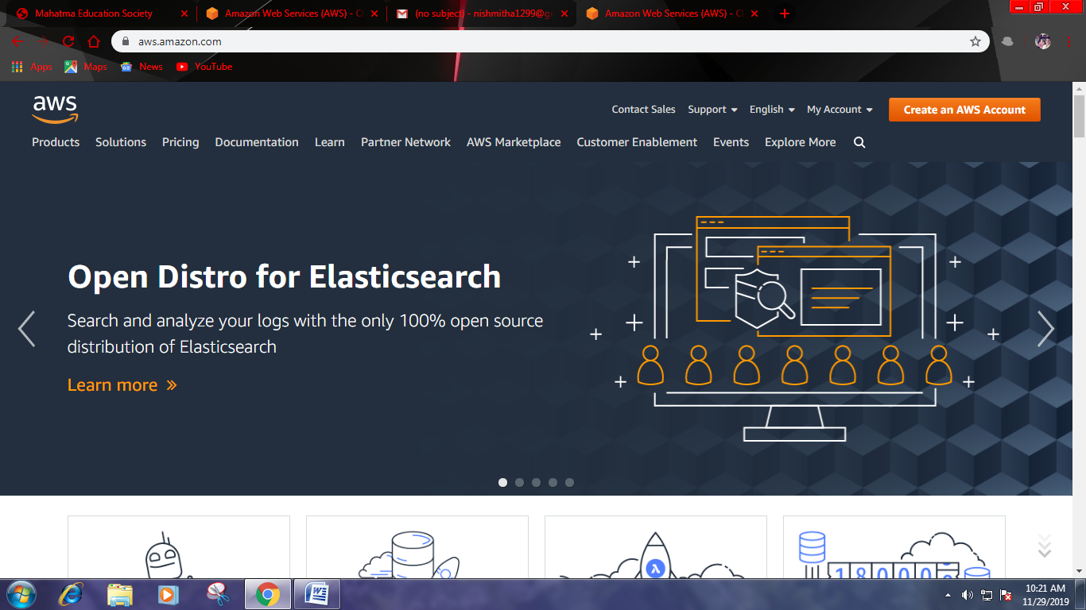

1. **Go to “My Account” > “AWS Management Console”.**

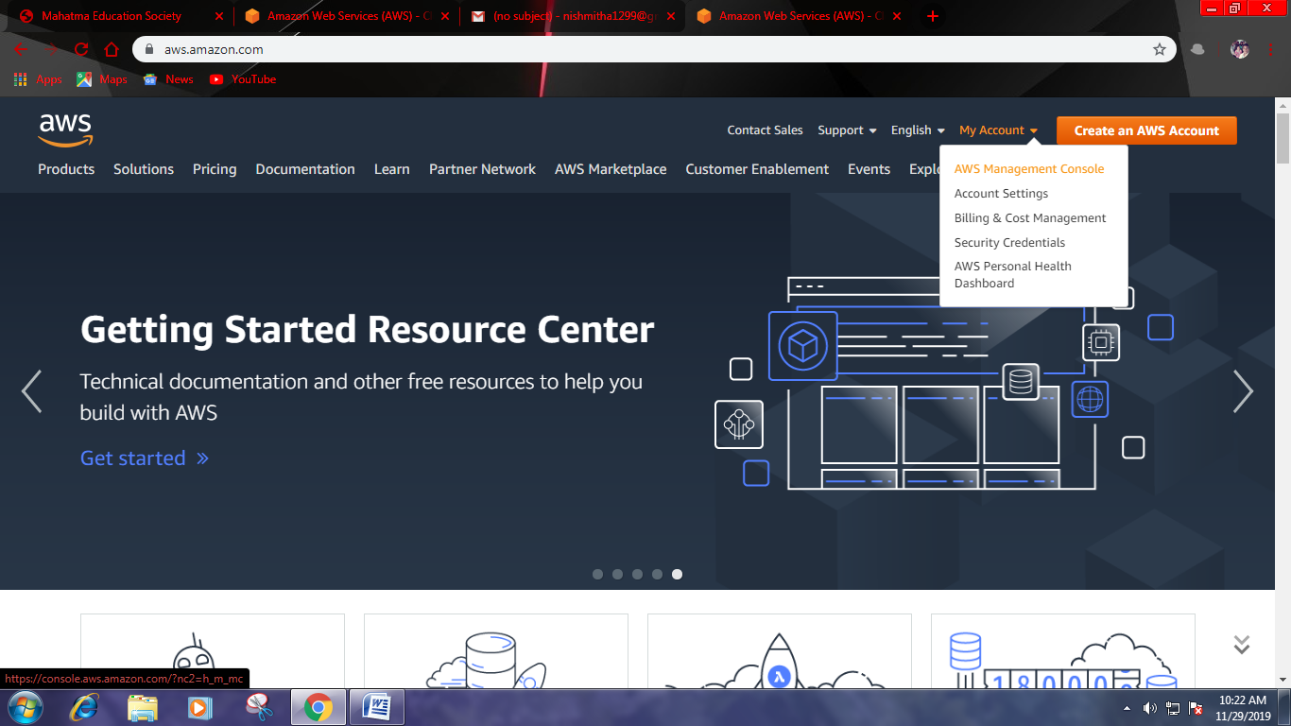

1. **Click on “Create a new AWS account”.**

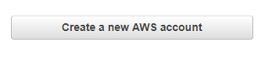

1. **Fill the form and click “Continue”.**
2. **Fill other details (fake details) and click on “Create Account and Continue”.**
3. **Now most crucial step AWS will ask for credit card details and other details. You have to close the browser.**
4. **Now again navigate to link below-https://aws.amazon.com/console/**
5. **Go to “My Account” > “AWS Management Console”.**
6. **Enter your ID and click on “Next”.**

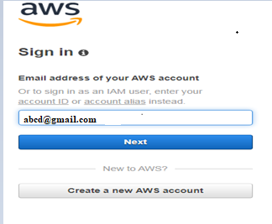

1. **Enter your password and click on “Sign in”.**

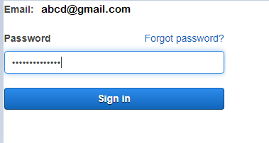

1. **Now it will redirect you to home page without asking any other details. Now we have to add user and group and assign them privileges.**
2. **Now go to “IAM”.**



1. **Click on “Users”.**

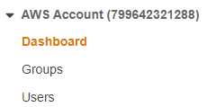

1. **Click on “Add User”.**



1. **Enter the name for the user. Check the check box in front of “Programmatic access” and “AWS Management Console access”.**

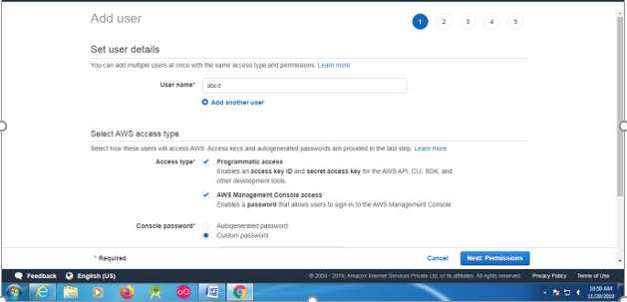

1. **Next it allow you to create group or you can just pass it. We are going to create group click on “Create group”.**

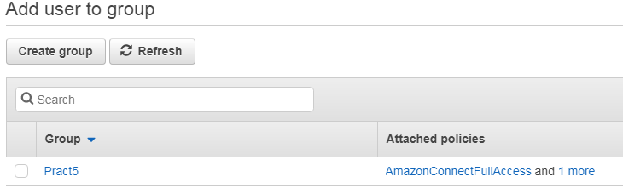

1. **Give name to group, assign the their permissions and click on “Create group”.**

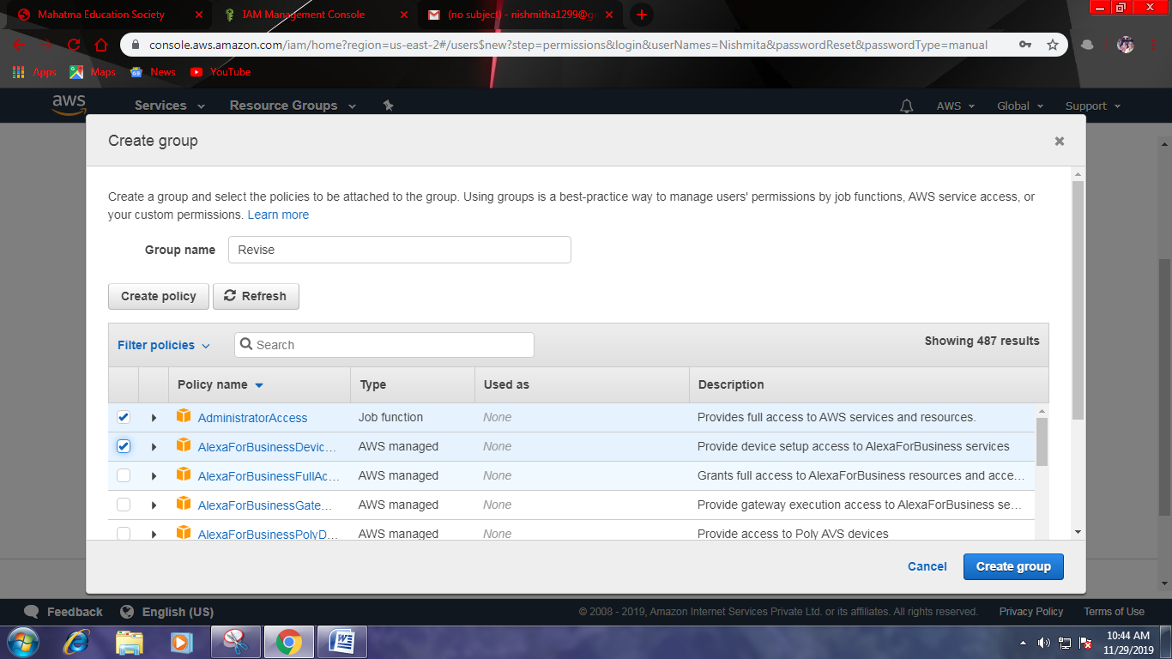

1. **Your group is created now click on “Next: Tags”.**

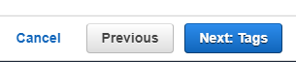

1. **Click on “Next: Review”.**



1. **Check the Review for the user and click on “Create user”.**
2. **Click on “Close”.**

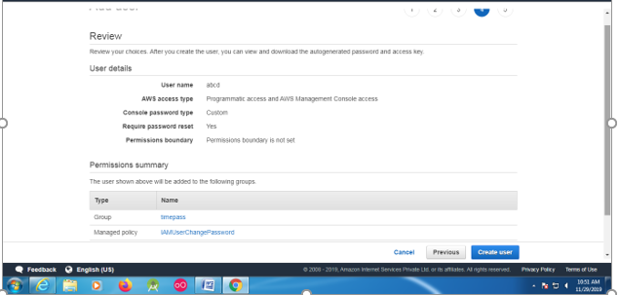

1. **Click on “Group”. You will see the group you just created.**

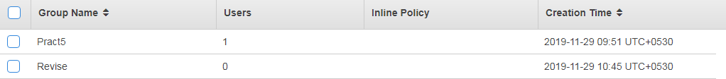

1. **Now log out of admin account and try to login as user (newly created).**
2. **Navigate to link below-**[**https://aws.amazon.com/console/**](https://aws.amazon.com/console/)
3. **Go to “My Account” > “AWS Management Console”.**
4. **Just login to your users account.**



1. **It will ask you to change the password which is been set by administrator.**

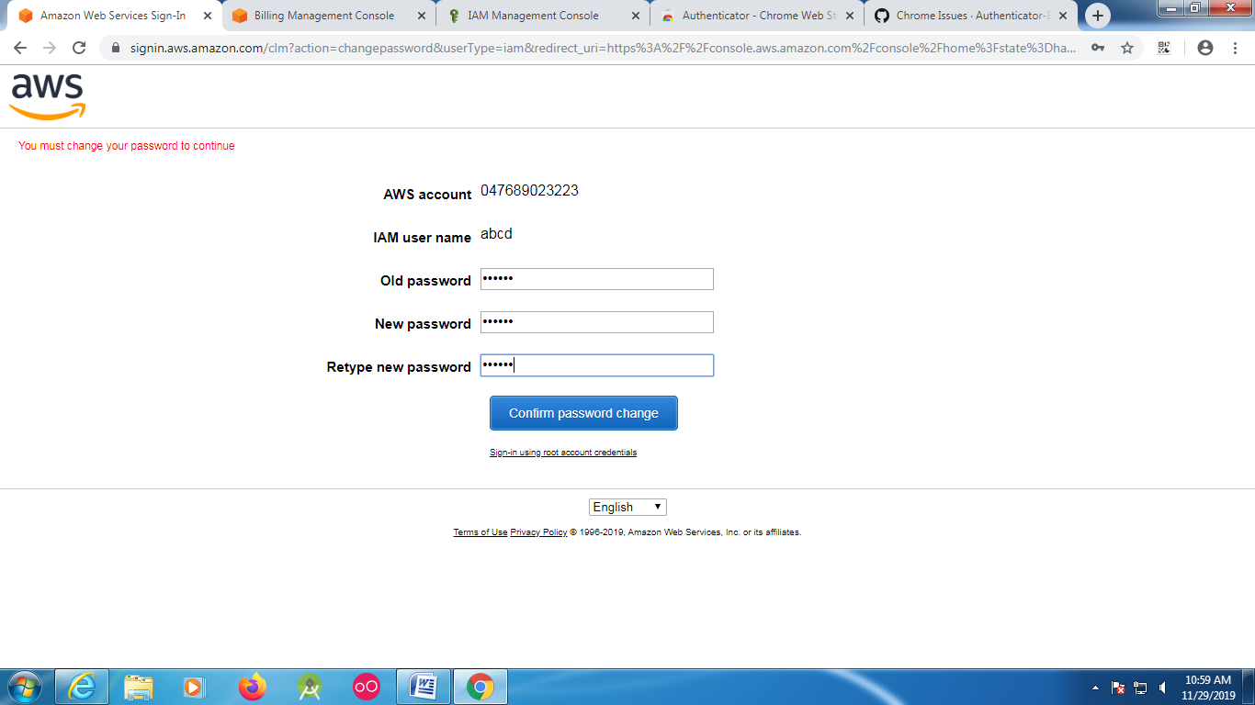

1. **You will be redirected to home screen.**

